**# Hypothesis 1a - Org Advancement, broad succession periods**

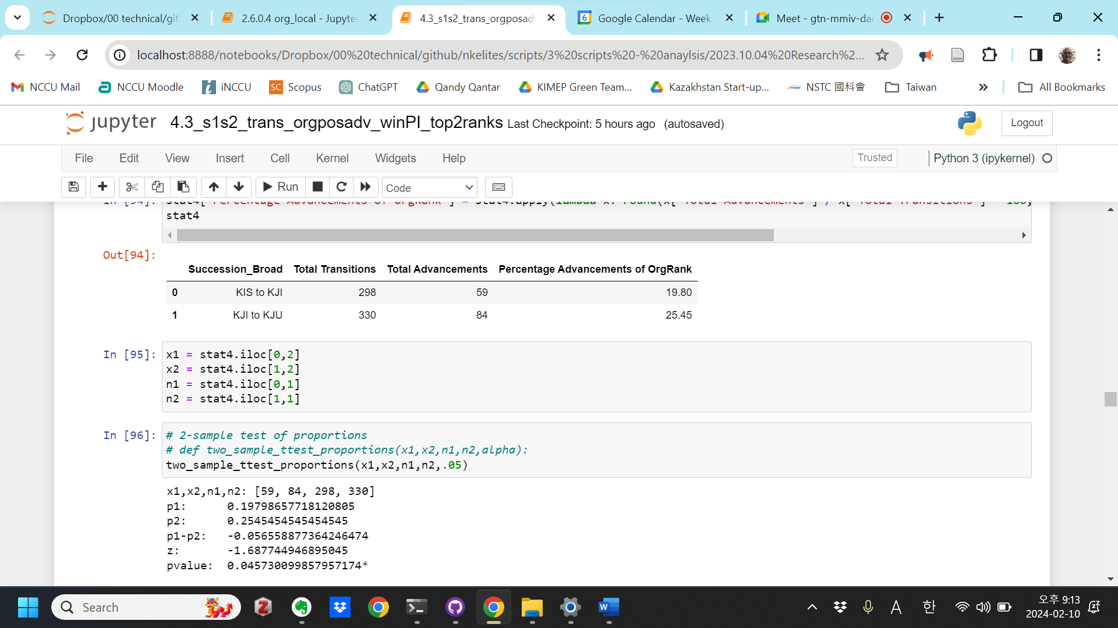

**# Hypothesis 1b - Position Advancement, broad succession periods**

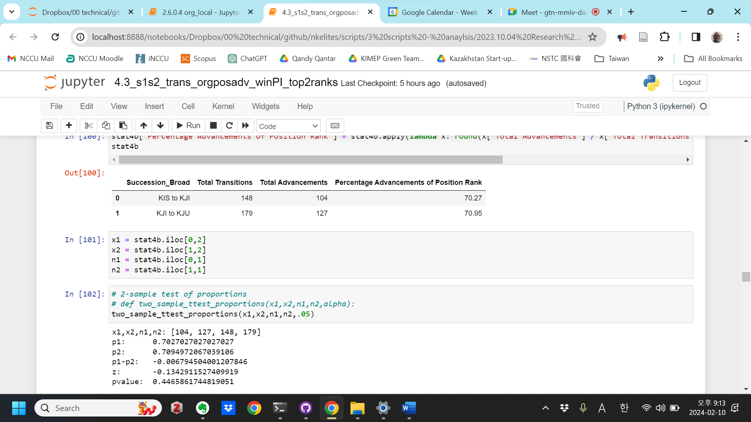

**# Hypothesis 1c - Org Advancement, broad succession, by Institution**

Government

Succession_Broad Total Transitions Total Advancements \

0 KIS to KJI 116 19

1 KJI to KJU 190 34

Percentage Advancements of OrgRank

0 16.38

1 17.89

x1,x2,n1,n2: [19, 34, 116, 190]

p1: 0.16379310344827586

p2: 0.17894736842105263

p1-p2: -0.015154264972776776

z: -0.3398624544967551

pvalue: 0.36698005616825735

Social

Succession_Broad Total Transitions Total Advancements \

0 KIS to KJI 27 3

1 KJI to KJU 17 2

Percentage Advancements of OrgRank

0 11.11

1 11.76

x1,x2,n1,n2: [3, 2, 27, 17]

p1: 0.1111111111111111

p2: 0.11764705882352941

p1-p2: -0.006535947712418305

z: -0.06651566609527824

pvalue: 0.4734836427950646

Party

Succession_Broad Total Transitions Total Advancements \

0 KIS to KJI 143 35

1 KJI to KJU 96 43

Percentage Advancements of OrgRank

0 24.48

1 44.79

x1,x2,n1,n2: [35, 43, 143, 96]

p1: 0.24475524475524477

p2: 0.4479166666666667

p1-p2: -0.20316142191142192

z: -3.283852109382434

pvalue: 0.0005119932068603505***

Military

Succession_Broad Total Transitions Total Advancements \

0 KIS to KJI 12 2

1 KJI to KJU 27 5

Percentage Advancements of OrgRank

0 16.67

1 18.52

x1,x2,n1,n2: [2, 5, 12, 27]

p1: 0.16666666666666666

p2: 0.18518518518518517

p1-p2: -0.018518518518518517

z: -0.13908716006604668

pvalue: 0.4446906371931195

**# Hypothesis 1d - Position Advancement, broad succession, by Institution**

Government

Succession_Broad Total Transitions Total Advancements \

0 KIS to KJI 59 46

1 KJI to KJU 120 71

Percentage Advancements

0 77.97

1 59.17

x1,x2,n1,n2: [46, 71, 59, 120]

p1: 0.7796610169491526

p2: 0.5916666666666667

p1-p2: 0.1879943502824859

z: 2.4848442165096536

pvalue: 0.006480406923956017**

Social

Succession_Broad Total Transitions Total Advancements \

0 KIS to KJI 17 14

1 KJI to KJU 9 8

Percentage Advancements

0 82.35

1 88.89

x1,x2,n1,n2: [14, 8, 17, 9]

p1: 0.8235294117647058

p2: 0.8888888888888888

p1-p2: -0.065359477124183

z: -0.43944003692053646

pvalue: 0.33017136079709886

Party

Succession_Broad Total Transitions Total Advancements \

0 KIS to KJI 65 37

1 KJI to KJU 36 34

Percentage Advancements

0 56.92

1 94.44

x1,x2,n1,n2: [37, 34, 65, 36]

p1: 0.5692307692307692

p2: 0.9444444444444444

p1-p2: -0.3752136752136752

z: -3.952368891530873

pvalue: 3.869066397377274e-05***

Military

Succession_Broad Total Transitions Total Advancements \

0 KIS to KJI 7 7

1 KJI to KJU 14 14

Percentage Advancements

0 100.0

1 100.0

x1,x2,n1,n2: [7, 14, 7, 14]

p1: 1.0

p2: 1.0

p1-p2: 0.0

z: nan

pvalue: nan

**# Hypothesis 2a - Org Advancement, narrow succession periods**

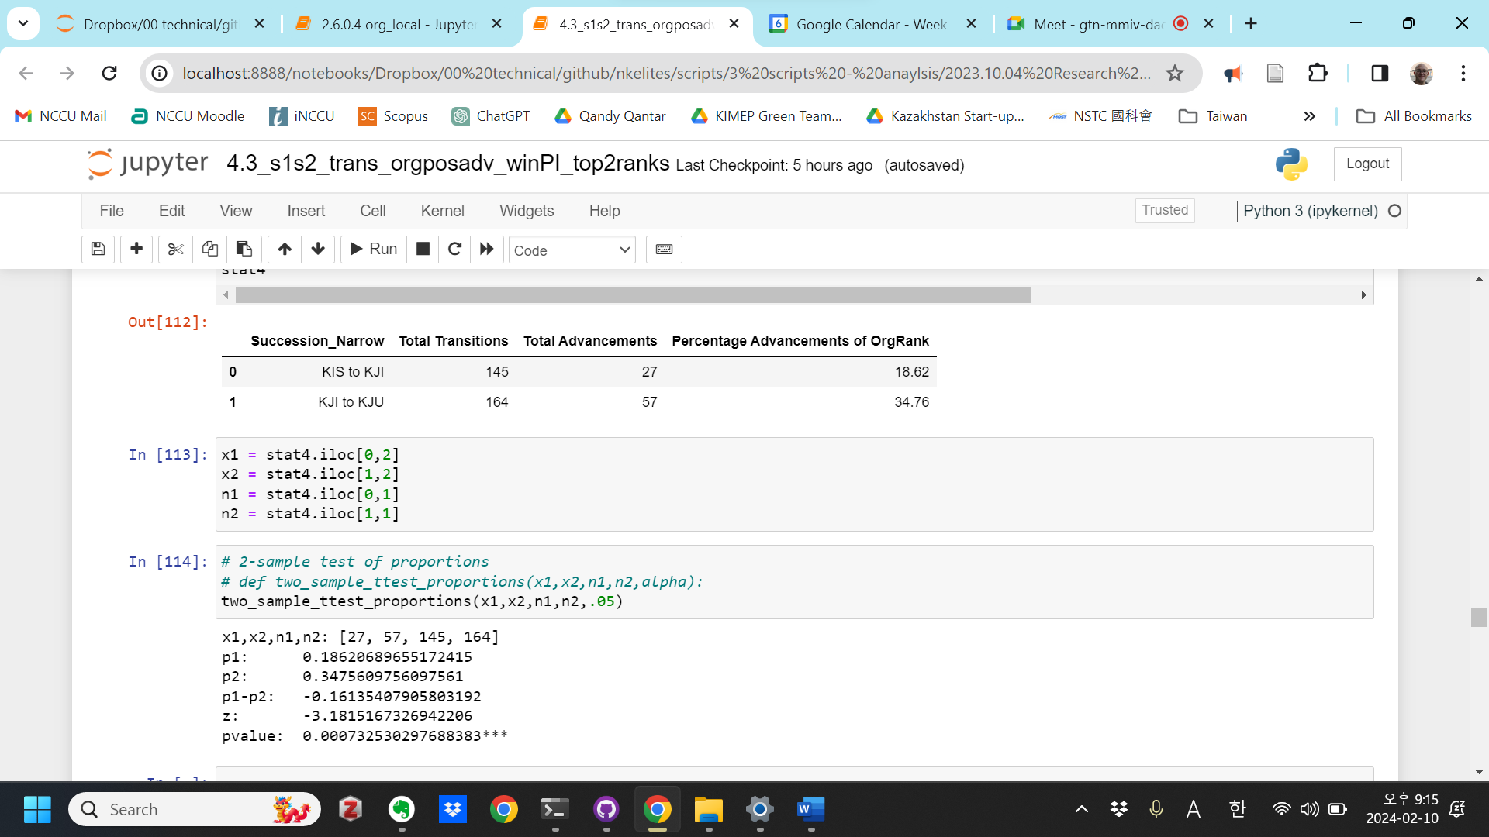

**# Hypothesis 2b - Position Advancement, narrow succession periods**

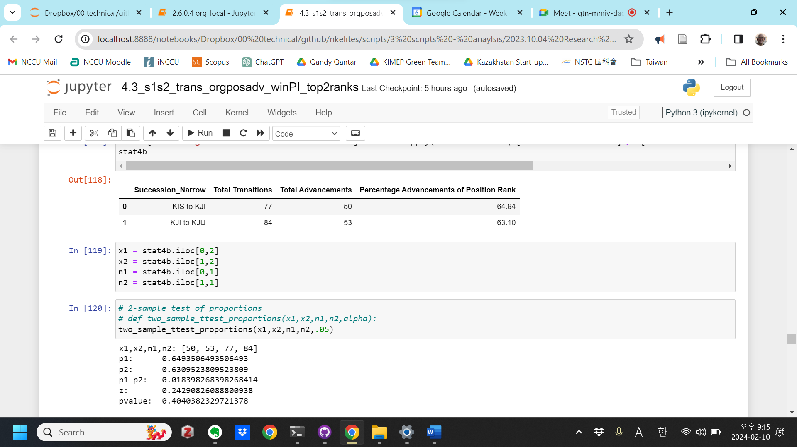

**# Hypothesis 2c - Org Advancement, narrow succession, by Institution**

Government

Succession_Narrow Total Transitions Total Advancements \

0 KIS to KJI 65 11

1 KJI to KJU 65 13

Percentage Advancements of OrgRank

0 16.92

1 20.00

x1,x2,n1,n2: [11, 13, 65, 65]

p1: 0.16923076923076924

p2: 0.2

p1-p2: -0.03076923076923077

z: -0.45210896443586523

pvalue: 0.3255952429886011

Social

Succession_Narrow Total Transitions Total Advancements \

0 KIS to KJI 7 1

1 KJI to KJU 1 False

Percentage Advancements of OrgRank

0 14.29

1 0.00

x1,x2,n1,n2: [1, False, 7, 1]

p1: 0.14285714285714285

p2: 0.0

p1-p2: 0.14285714285714285

z: 0.40406101782088427

pvalue: 0.34308392492761963

Party

Succession_Narrow Total Transitions Total Advancements \

0 KIS to KJI 66 13

1 KJI to KJU 85 43

Percentage Advancements of OrgRank

0 19.70

1 50.59

x1,x2,n1,n2: [13, 43, 66, 85]

p1: 0.19696969696969696

p2: 0.5058823529411764

p1-p2: -0.3089126559714795

z: -3.8980713988054516

pvalue: 4.848091543152577e-05***

Military

Succession_Narrow Total Transitions Total Advancements \

0 KIS to KJI 7 2

1 KJI to KJU 13 1

Percentage Advancements of OrgRank

0 28.57

1 7.69

x1,x2,n1,n2: [2, 1, 7, 13]

p1: 0.2857142857142857

p2: 0.07692307692307693

p1-p2: 0.20879120879120877

z: 1.2472767145898402

pvalue: 0.10614802621222108

**# Hypothesis 2d - Position Advancement, narrow succession, by Institution**

Government

Succession_Narrow Total Transitions Total Advancements \

0 KIS to KJI 38 27

1 KJI to KJU 47 17

Percentage Advancements

0 71.05

1 36.17

x1,x2,n1,n2: [27, 17, 38, 47]

p1: 0.7105263157894737

p2: 0.3617021276595745

p1-p2: 0.3488241881298992

z: 3.1999155409463587

pvalue: 0.000687339322961722***

Social

Succession_Narrow Total Transitions Total Advancements \

0 KIS to KJI 6 3

1 KJI to KJU 0 0

Percentage Advancements

0 50.0

1 NaN

x1,x2,n1,n2: [3, 0, 6, 0]

p1: 0.5

p2: nan

p1-p2: nan

z: nan

pvalue: nan

Party

Succession_Narrow Total Transitions Total Advancements \

0 KIS to KJI 30 17

1 KJI to KJU 30 29

Percentage Advancements

0 56.67

1 96.67

x1,x2,n1,n2: [17, 29, 30, 30]

p1: 0.5666666666666667

p2: 0.9666666666666667

p1-p2: -0.4

z: -3.662806174004159

pvalue: 0.0001247336511635***

Military

Succession_Narrow Total Transitions Total Advancements \

0 KIS to KJI 3 3

1 KJI to KJU 7 7

Percentage Advancements

0 100.0

1 100.0

x1,x2,n1,n2: [3, 7, 3, 7]

p1: 1.0

p2: 1.0

p1-p2: 0.0

z: nan

pvalue: nan